**CUSTOMER CARE REGISTRY**

**INTRODUCTION:**

Customer care is more than just providing great customer service. It’s a proactive approach to providing information, tools, and services to customers at each point they interact with a brand.

High-quality customer care is proactive. The needs of customers throughout the buyer’s journey are anticipated, making customers feel supported. That, in turn, helps create an emotional connection between the customer and the company. Customer service is reactive. Here, the focus is on helping customers solve problems or answer questions before purchase, either in a self-serve fashion or via the customer support team. If a company neglects customer care, it can negatively impact the customer service experience. For example, when a website chatbot can’t provide key information about a product, customers are more likely to get frustrated and reach out to a customer service agent for help. This places a greater burden on the support team to quickly address the issue and mitigate any effects of the negative experience. To achieve the best customer service, your customer service team should address customer needs quickly and with as few customer interactions as possible. According to McKinsey executives for too long focused on improving specific touchpoints, overlooking the needs of the entire customer. McKinsey notes that as customer expectations evolve, companies must consider the customer experience from the first website visit to troubleshooting issues with a purchase.

**PROBLEM STATEMENT:**

This Application has been developed to help the customer in processing their complaints. The customers can raise the ticket with a detailed description of the issue. An Agent will be assigned to the Customer to solve the problem. Whenever the agent is assigned to a customer, they will be notified with an email alert. Customers can view the status of the ticket till the service is provided.

Admin: The main role and responsibility of the admin are to take care of the whole process. Starting from Admin login followed by the agent creation and assigning the customer's complaints. Finally, He will be able to track the work assigned to the agent and a notification will be sent to the customer.

User: They can register for an account. After the login, they can create the complaint with a description of the problem they are facing. Each user will be assigned with an agent. They can view the status of their complaint.

**HARDWARE REQUIREMENTS:**

1. 8gb Ram
2. Intel Core I3
3. OS-Windows/Linux/MacOS
4. Laptop or Desktop

**SOFTWARE REQUIREMENTS:**

1. Python
2. Flask
3. Docker

**FEATURES:**

1. It helps the company to manage their client in an efficient way possible
2. In the web application, admin can be able to allocate the agent suitable for the user determined by their complaints
3. Several areas, Communication pave a major role in maintaining or running the organization. Hence registering the complaints of the user and tries to solve it really helps the growth of the company.

**TECHNICAL ARCHITECTURE:**

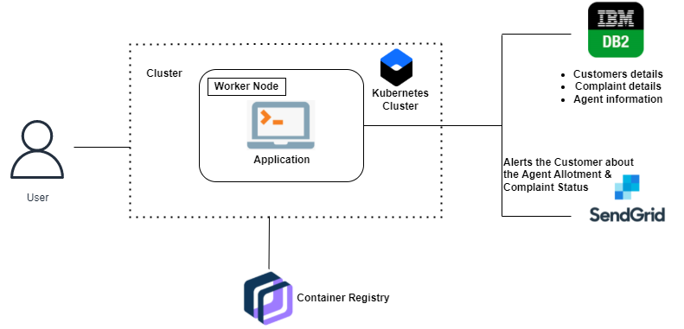

**CONCLUSION:**

Consumer expectations are extremely high, putting increased pressure on companies to improve their customer relationships. According to Forrester only 18% of customers said they would continue doing business with a brand that has disappointed them. In addition, poor customer care is costly. That same Forrester report showed that ecommerce retailers suffer, on average, USD 22 million in unnecessary service costs due to channel escalation. Adding to this pressure is the number of customer service channels today. Social media, email, call centers, chatbots, and text add numerous touchpoints and complexity to customer service operations. This can lead to lost information when the same person reaches out via multiple channels. When a customer service agent doesn’t know the whole story and the customer has to repeatedly share the problem, it leaves both people frustrated. Call centers and direct customer service agent interactions are still vital to any customer service department, but they are costly to run and can have a high rate of employee turnover. Chatbots, social media messaging, and other self-serve options have drawbacks as well, despite their convenience, including slow response time and inaccurate, irrelevant answers that require the customer to escalate the conversation to another channel.